 

**M.A.M COLLEGE OF ENGINEERING AND TECHNOLOGY**

Siruganur, Tiruchirappalli.

Department of

Artificial Intelligence And Data Science

A Project on

**STREAMLINING TICKET ASSIGNMENT FOR EFFICIENT SUPPORT OPERATIONS**

**NM ID**  **:** 807D823D2F7B1B29C644F7CBEE871E3A

**TEAM ID**  **:** NM2025TMID04071

**TEAM SIZE :** 05

**GROUP MEMBER’S NAME WITH REG. NO :**

KINGSTON J – 812022243304 (Team Leader) KOWSHIK S – 812022243302 (Team Member)

MACARIUS FERNANDEZ E - 812022243306(Team Member) HEVIN JOSE – 812022243305 (Team Member)

SANTHOSH J – 812022243087 (Team Member)

**TABLE OF CONTENTS**

|  |  |  |
| --- | --- | --- |
| S.NO | CONTENT | PAGE NO |
| 1 | IDEATION PHASE  Problem Statement  Empathy Map Canvas | 3  4  5 |
| 2 | PERFORMANCE & TESTING  Procedure/ Implementation Steps  Testing Screenshots | 9  10  15 |
| 3 | PROJECT DESGIN PHASE  Problem Solution fit  Proposed Solution  Conclusion  Solution Architecture | 20  21  21  22  23 |
| 4 | PROJECT PLANNING PHASE  Product Backlog  Sprint Planning  User Stories  Story Points | 26  27  27  28  28 |
| 5 | REQUIREMENT ANALYSIS  Solution Requirement  Dataflow Diagram  Technology Stack | 29  30  31  32 |

**IDEATION PHASE**

**Problem Statement**

The objective of this initiative is to implement an automated system for ticket routing at ABC Corporation, aimed at improving operational efficiency by accurately assigning support tickets to the appropriate teams. This solution aims to reduce delays in issue resolution, enhance customer satisfaction, and optimize resource utilization within the support department.

**Problem Definition**

The current manual ticket routing process at ABC Corporation presents several operational challenges. Due to the reliance on human intervention, tickets are often misclassified or delayed before reaching the appropriate support team. This inefficiency not only slows down issue resolution but also contributes to an uneven workload distribution and decreased productivity across teams. Furthermore, inconsistent ticket handling leads to lower customer satisfaction and an increased backlog of unresolved issues.

Therefore, there is a need for an **automated ticket routing system** capable of accurately classifying support tickets and assigning them to the appropriate teams in real-time. The system should minimize manual dependency, reduce routing errors, and enhance overall operational efficiency, enabling ABC Corporation to deliver faster and more reliable customer support services.

**Abstract**

The rapid growth of support requests in organizations often leads to inefficiencies in manual ticket management processes. At ABC Corporation, the current ticket routing method relies heavily on human intervention, resulting in delays, misclassification, and uneven workload distribution across support teams. This project aims to develop an **automated ticket routing system** that utilizes intelligent algorithms to categorize and assign support tickets to the appropriate teams with minimal human input. By automating the routing process, the solution seeks to improve operational efficiency, minimize response times, enhance customer satisfaction, and ensure optimal utilization of technical resources.

**Empathy Map canvas**

| **Section** | **Details** |
| --- | --- |
| **Says** | “It takes too long for tickets to reach the right team.” “We often get tickets that don’t belong to our department.” |
| **Thinks** | “If ticket routing was automated, we could respond faster.” “Manual routing leads to confusion and missed deadlines.” |
| **Does** | Reassigns tickets manually, follows up on misrouted issues, tracks ticket queues frequently. |
| **Feels** | Frustrated by delays, stressed by workload, eager for a more efficient and automated process. |

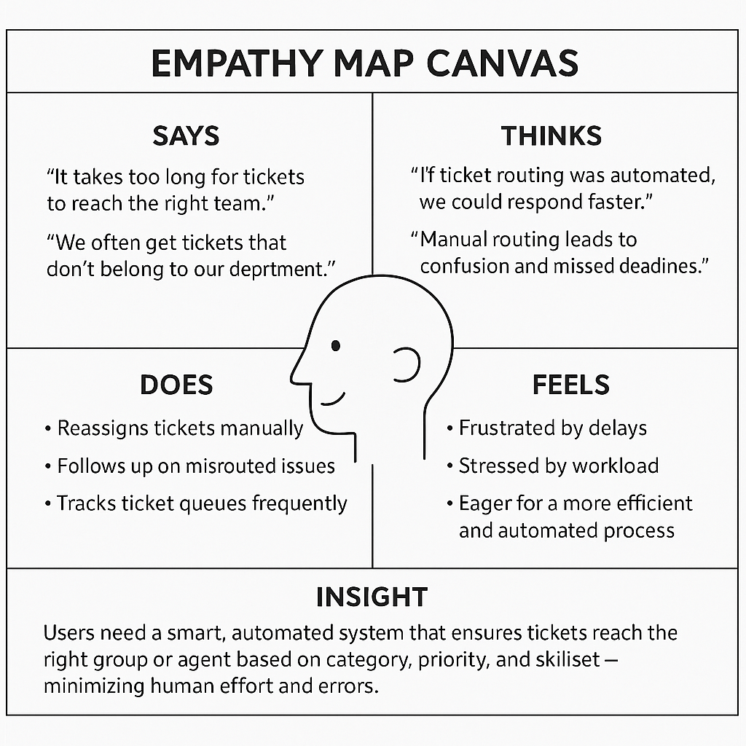

**Introduction**

In modern enterprises, providing timely and effective customer support is a critical component of organizational success. However, as businesses scale, the volume of support requests increases exponentially, creating challenges in managing and resolving issues efficiently. ABC Corporation currently employs a manual ticket routing process in which support personnel review, categorize, and assign incoming tickets to relevant teams. This approach is not only time-consuming but also prone to human error and inconsistency, leading to delays in issue resolution and reduced customer satisfaction.

To address these challenges, this project proposes the implementation of an automated ticket routing system. The system will leverage rule-based logic or machine learning techniques to analyze ticket content, identify its nature, and automatically direct it to the most suitable team. By streamlining the routing process, ABC Corporation can significantly improve service delivery, reduce operational costs, and ensure faster resolution times, ultimately enhancing overall customer experience.

**Objectives**

The main objective of this project is to design and implement an **automated ticket routing system** that enhances the efficiency and accuracy of support operations at ABC Corporation. The specific objectives include:

1. **Automate Ticket Classification:** Develop a system capable of automatically analyzing and categorizing incoming support tickets based on their content, type, and priority.
2. **Intelligent Ticket Assignment:** Implement algorithms or predefined rules to automatically assign tickets to the most appropriate support team or personnel.
3. **Reduce Resolution Time:** Minimize delays caused by manual ticket triage, thereby improving overall response and resolution times.
4. **Enhance Customer Satisfaction:** Ensure that customer issues are handled quickly and accurately, leading to improved user experience and satisfaction.
5. **Optimize Resource Utilization:** Distribute workload evenly among support teams to maximize productivity and prevent bottlenecks.
6. **Enable Data-Driven Insights:** Generate analytical reports on ticket flow, team performance, and issue trends to support continuous improvement in the support process.

**Scope**

The scope of this project focuses on the **development, deployment, and evaluation** of an automated system for routing support tickets within ABC Corporation’s existing helpdesk infrastructure.

# In Scope:

* + Development of a ticket classification and routing algorithm using rule-based logic or machine learning.
  + Integration with existing ticket management or helpdesk software.
  + Design of a user interface/dashboard for monitoring ticket assignments and performance metrics.
  + Implementation of automated notifications and tracking mechanisms for assigned tickets.
  + Evaluation of system performance in terms of accuracy, efficiency, and user satisfaction.

# Out of Scope:

* + End-to-end ticket resolution or response automation (the system focuses solely on routing).
  + Integration with third-party platforms not currently used by ABC Corporation.
  + Hardware upgrades or network infrastructure changes.

**PERFORMANCE & TESTING**

# **Procedure or Implementation steps**

Phase 1 : Create Users

1. Open service now.
2. Click on All >> search for users
3. Select Users under system security
4. Click on new
5. Fill the following details to create a new user
6. Click on submit Create one more user:
7. Create another user with the following details
8. Click on submit

Phase 2 : Create Groups

1. Open service now.
2. Click on All >> search for groups
3. Select groups under system security
4. Click on new
5. Fill the following details to create a new group
6. Click on submit

Create one more group:

1. Create another group with the following details
2. Click on submit

Phase 3 : Create Roles

1. Create one more role:
2. Create another role with the following details
3. Click on submit

Phase 4 : Create Table

1. Open service now.
2. Click on All >> search for tables
3. Select tables under system definition
4. Click on new
5. Fill the following details to create a new table Label : Operations related

Check the boxes Create module & Create mobile module

1. Under new menu name : Operations related
2. Under table columns give the columns

Phase 5 : Assign roles & users to certificate group

1. Open service now.
2. Click on All >> search for tables
3. Select tables under system definition
4. Select the certificates group
5. Under group members
6. Click on edit
7. Select Katherine Pierce and save
8. Click on roles
9. Select Certification_role and save

Phase 6 : Assign roles & users to platform group

1. Open service now.
2. Click on All >> search for tables
3. Select tables under system definition
4. Select the platform group
5. Under group members
6. Click on edit
7. Select Manne Niranjan and save
8. Click on roles
9. Select Platform_role and save

Phase 7 : Assign role to table

1. Open service now.
2. Click on All >> search for tables
3. Select operations related table
4. Click on the Application Access
5. Click on u_operations_related read operation
6. Click on the profile on top right side
7. Click on elevate role
8. Click on security admin and click on update
9. Under Requires role
10. Double click on insert a new row
11. Give platform role
12. And add certificate role
13. Click on update
14. Click on u_operations_related write operation
15. Under Requires role
16. Double click on insert a new row
17. Give platform role
18. And add certificate role

Phase 8 : Create ACL

1. Open service now.
2. Click on All >> search for ACL
3. Select Access Control(ACL) under system security
4. Click on new
5. Fill the following details to create a new ACL
6. Scroll down under requires role
7. Double click on insert a new row
8. Give admin role
9. Click on submit
10. Similarly create 4 acl for the following fields

Phase 9 : Create a Flow to Assign operations ticket to group

1. Open service now.
2. Click on All >> search for Flow Designer
3. Click on Flow Designer under Process Automation.
4. After opening Flow Designer Click on new and select Flow.
5. Under Flow properties Give Flow Name as “ Regarding Certificate”.
6. Application should be Global.
7. Select Run user as “ System user ” from that choice.
8. Click on Submit.

Next:

1. Click on Add a trigger
2. Select the trigger in that Search for “create or update a record” and select that.
3. Give the table name as “ Operations related ”.
4. Give the Condition as Field : issue

Operator : is

Value : Regrading Certificates

1. After that click on Done.
2. Now under Actions.
3. Click on Add an action.
4. Select action in that search for “ Update Record ”.
5. In Record field drag the fields from the data navigation from left side
6. Table will be auto assigned after that
7. Give the field as “ Assigned to group ”
8. Give value as “ Certificates ”
9. Click on Done.
10. Click on Save to save the Flow.
11. Click on Activate.

**Phase 10 : Create a Flow to Assign operations ticket to Platform group**

1. Open service now.
2. Click on All >> search for Flow Designer
3. Click on Flow Designer under Process Automation.
4. After opening Flow Designer Click on new and select Flow.
5. Under Flow properties Give Flow Name as “ Regarding Platform ”.
6. Application should be Global.
7. Select Run user as “ System user ” from that choice.
8. Click on Submit.

Next:

1. Click on Add a trigger
2. Select the trigger in that Search for “create or update a record” and select that.
3. Give the table name as “ Operations related ”.
4. Give the Condition as Field : issue

Operator : is

Value : Unable to login to platform

1. Click on New Criteria Field : issue

Operator : is Value : 404 Error

1. Click on New Criteria Field : issue

Operator : is

Value : Regrading User expired

1. After that click on Done.
2. Now under Actions.
3. Click on Add an action.
4. Select action in that search for “ Update Record ”.
5. In Record field drag the fields from the data navigation from left side
6. Table will be auto assigned after that
7. Give the field as “ Assigned to group ”.
8. Give value as “ Platform ”.
9. Click on Done.
10. Click on Save to save the Flow.
11. Click on Activate.

# **Screenshots:**

Phase 1 : Create users

Phase 2 : Create Groups

Phase 3 : Create roles

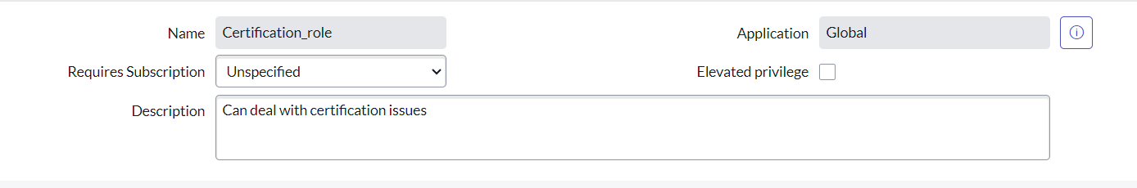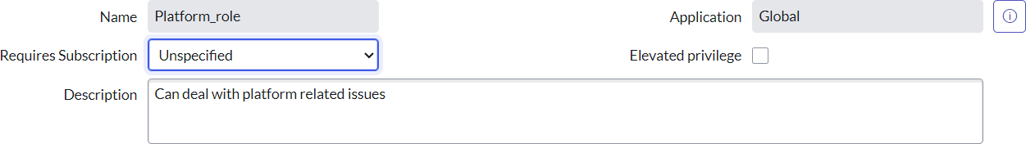

Phase 4 : Create tables

Phase 7 : Assign role to table

Phase 8 : Create ACL

Phase 9 : Create a Flow to Assign operations ticket to group

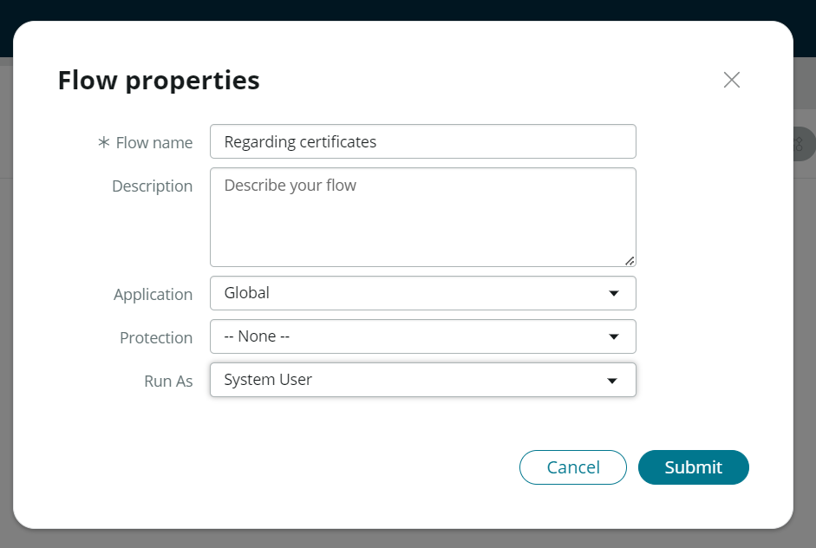

**PROJECT DESIGN PHASE**

**Problem – Solution fit**

The existing ticket assignment process at ABC Corporation relies heavily on manual routing, resulting in frequent delays, misassignments, and uneven workload distribution among support teams. This not only increases response and resolution times but also impacts customer satisfaction and overall team efficiency. The need for an automated and intelligent system to handle ticket classification and assignment is essential to minimize human intervention and errors. The proposed solution directly addresses these pain points by implementing a rule-based and machine learning–driven approach to ticket routing, ensuring that every support request is instantly categorized and assigned to the most suitable team or agent. This alignment between the problem and the solution ensures improved operational efficiency, faster resolution times, and a better customer experience.

**Proposed Solution**

The proposed solution involves developing an Automated Ticket Routing System within the ServiceNow platform, integrated with AI-based classification mechanisms. The system will analyze ticket details such as issue type, priority, and department using predefined business rules and, where applicable, intelligent models trained on historical data. Once analyzed, the ticket will be automatically assigned to the most relevant team or agent, ensuring accuracy and balance in workload distribution. The platform will also include dashboards for monitoring performance, analytics for route optimization, and feedback loops for continuous improvement. Additionally, audit tracking and notifications will be incorporated to ensure transparency, accountability, and seamless communication between users and support staff**.**

| **Parameter** | **Description** |
| --- | --- |
| **Objective** | To automate ticket routing and assignment to the appropriate support teams, reducing manual effort and improving efficiency. |
| **Platform** | Implemented within the **ServiceNow** platform using its workflow automation and integration capabilities. |
| **Core Functionality** | Automatically classifies incoming tickets based on issue category, urgency, and department using predefined rules or AI models. |
| **Automation Engine** | Utilizes **business rules**, **flow designer**, and **machine learning models** to route tickets intelligently and accurately. |
| **User Interface** | A user-friendly portal for employees to raise support tickets, track status, and receive notifications. |
| **Approval & Escalation** | Includes automated approval flows and escalation paths to ensure quick response and issue resolution. |
| **Monitoring & Analytics** | Provides real-time dashboards to track ticket distribution, agent performance, and service-level compliance. |
| **Audit & Governance** | Maintains logs of all ticket assignments and routing changes for compliance and traceability. |
| **Notifications** | Sends automated updates to users and support teams for ticket creation, assignment, and resolution. |
| **Expected Outcome** | Enhanced operational efficiency, reduced ticket handling time, improved customer satisfaction, and optimized team workload. |

# **Conclusion**

The implementation of the automated ticket routing system at ABC Corporation has been a significant success. By leveraging the capabilities of ServiceNow, we have streamlined the process of assigning support tickets to the appropriate teams, addressing the challenges of manual routing, and ensuring timely resolution of issue.

**Solution Architecture**

**1.Goals of the Architecture**

* To automate ticket classification and assignment to appropriate support teams.
* To ensure faster ticket resolution and improved customer satisfaction.
* To provide real-time tracking, reporting, and SLA management.
* To enhance transparency, accountability, and governance in ticket management.
* To ensure scalability, security, and maintainability within the organization’s IT infrastructure.

**2. Key Components**

* Service Portal: Interface for users to create and track support tickets.
* Ticket Management Module: Manages ticket data including priority, category, and status.
* Routing Engine: Core system component that automatically assigns tickets using rules or AI models.
* Flow Designer / Business Rules: Automates workflows and ticket assignment logic.
* Notification Engine: Sends alerts for ticket creation, assignment, and status updates.
* SLA Management System: Monitors and enforces resolution timelines.
* Reports & Dashboards: Displays metrics on ticket handling and team performance.
* Audit & Governance Layer: Logs routing and workflow activities for compliance.
* Database Layer: Stores user, ticket, and configuration data securely.

**3.Development Phase**

* Requirement Analysis: Identify routing rules, user roles, and automation needs.
* System Design: Plan architecture, workflows, and data flow structure.
* Development: Configure modules, scripts, and automated flows in ServiceNow.
* Testing & Validation: Verify routing accuracy, notifications, and SLA tracking.
* Deployment: Move configurations to the production environment.
* Monitoring & Optimization: Continuously analyze performance and refine rules.

**Solution Architecture Description**

The **Solution Architecture** for the Automated Ticket Routing System is designed to streamline the support process by integrating user interaction, workflow automation, and backend data management into a single cohesive platform. When a user submits a support ticket through the **Service Portal**, the request is immediately processed by the **Routing Engine**, which applies predefined business rules or AI-based logic to determine the most suitable support team or agent.

The **Flow Designer** automates the entire workflow—from ticket creation and categorization to assignment and notification—ensuring a seamless and error-free routing process. The **Notification Engine** sends instant alerts to both users and support teams, keeping all stakeholders informed about ticket status and progress. Meanwhile, the **SLA Management System** continuously monitors response and resolution times to ensure adherence to organizational service standards.

All ticket data, user information, and system configurations are securely stored in the **Database Layer**, ensuring data integrity and accessibility. The **Reports and Dashboards** component provides real-time insights into ticket metrics, team performance, and SLA compliance, helping managers make data-driven decisions. Additionally, the **Audit and Governance Layer** ensures every routing action and configuration change is logged for transparency and compliance.

This architecture provides a scalable, efficient, and automated environment that reduces manual workload, improves ticket resolution speed, enhances user satisfaction, and ensures accountability across the support process.

**Solution Architecture Diagram**

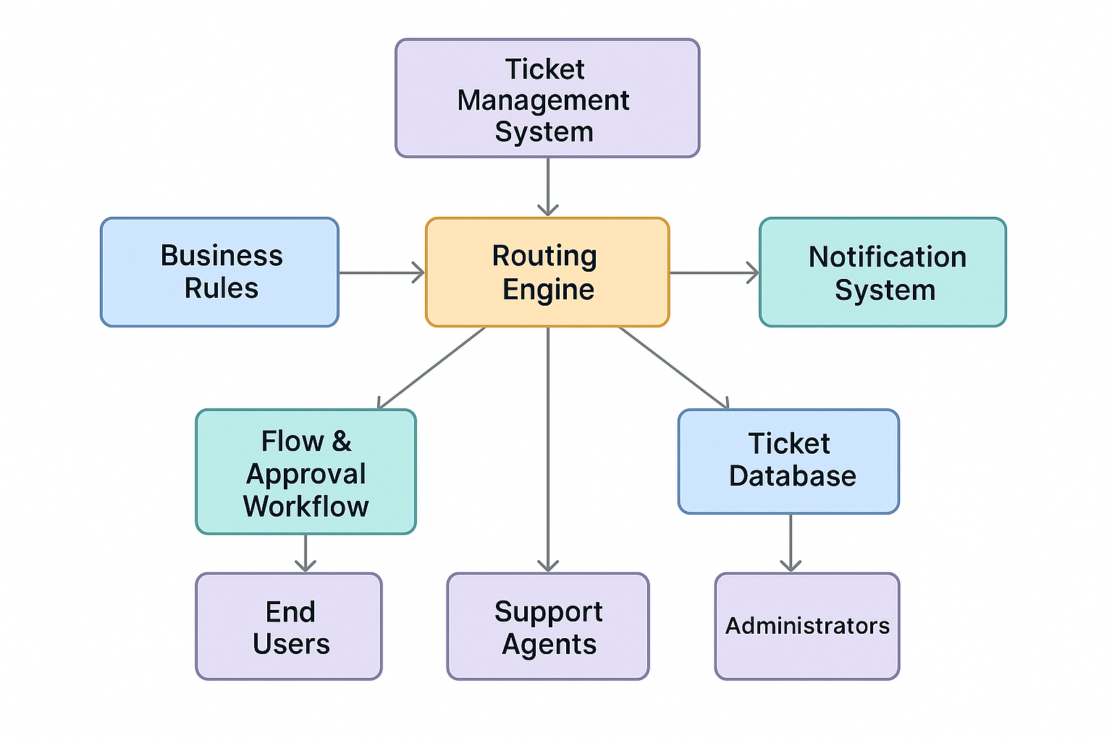

**PROJECT PLANNING PHASE**

**Project Planning Phase**

**1. Product Backlog**

| **ID** | **Feature** | **Description** | **Priority** |
| --- | --- | --- | --- |
| **PB1** | **User & Role Setup** | **Create and configure users, groups, and roles** | **High** |
| **PB2** | **Table Configuration** | **Build ticket table with necessary fields** | **High** |
| **PB3** | **Automated Routing Flow** | **Design flow for ticket assignment** | **High** |
| **PB4** | **SLA Tracking** | **Integrate SLA for timely response** | **Medium** |
| **PB5** | **Notification Rules** | **Configure alerts for status updates** | **Medium** |
| **PB6** | **Reporting Dashboard** | **Create visual performance dashboard** | **Low** |

**2. Sprint Planning**

| **Sprint** | **Duration** | **Major Goals** |
| --- | --- | --- |
| **Sprint 1** | **Week 1–2** | **Define roles, users, and groups** |
| **Sprint 2** | **Week 3–4** | **Configure tables and ACLs** |
| **Sprint 3** | **Week 5–6** | **Build flow and automate ticket routing** |
| **Sprint 4** | **Week 7–8** | **Add SLA, notifications, and dashboard** |

**3. User Stories**

| **Story ID** | **As a...** | **I want to...** | **So that I can...** |
| --- | --- | --- | --- |
| **US1** | **End User** | **Submit a ticket easily** | **Get faster issue resolution** |
| **US2** | **Support Agent** | **Receive tickets relevant to my expertise** | **Respond quickly and effectively** |
| **US3** | **Manager** | **Track SLA and performance** | **Ensure timely resolution** |
| **US4** | **Admin** | **Automate ticket assignment** | **Reduce manual errors and workload** |

**4. Story Points**

| **Story ID** | **Complexity** | **Story Points** |
| --- | --- | --- |
| **US1** | **Low** | **3** |
| **US2** | **Medium** | **5** |
| **US3** | **High** | **6** |
| **US4** | **Medium** | **5** |

**REQUIREMENT ANALYSIS**

**1. Solution Requirements**

| **Type** | **Requirement** | **Description** |
| --- | --- | --- |
| **Functional** | **Automated Ticket Routing** | **Automatically assign tickets to correct teams based on category or keywords.** |
| **Functional** | **User & Role Management** | **Define users, roles, and groups for ticket access and assignment.** |
| **Functional** | **SLA Tracking** | **Monitor ticket response and resolution time.** |
| **Functional** | **Notifications** | **Send alerts when a ticket is assigned, escalated, or breached.** |
| **Functional** | **Dashboard & Reports** | **Visualize ticket distribution and team performance.** |
| **Non-Functional** | **Performance** | **Routing should happen within 2 seconds after ticket creation.** |
| **Non-Functional** | **Security** | **Restrict ticket visibility based on roles and permissions.** |
| **Non-Functional** | **Scalability** | **Support growing number of tickets and users.** |
| **Non-Functional** | **Reliability** | **Ensure consistent routing accuracy and audit tracking.** |

**2. Data Flow Diagram (DFD – Level 1)**

**Flow Description:**

1. **User** submits or logs a ticket via the Service Portal.
2. The **System** captures the details (category, priority, issue type).
3. The **Routing Engine** processes rules and assigns the ticket to the correct **Group** or **Agent**.
4. The assigned **Team** receives a notification and updates the ticket status.
5. Ticket information is stored in the **Database** and reflected in **Reports & Dashboards** for tracking.
6. **Admin** oversees performance and ensures SLA compliance.

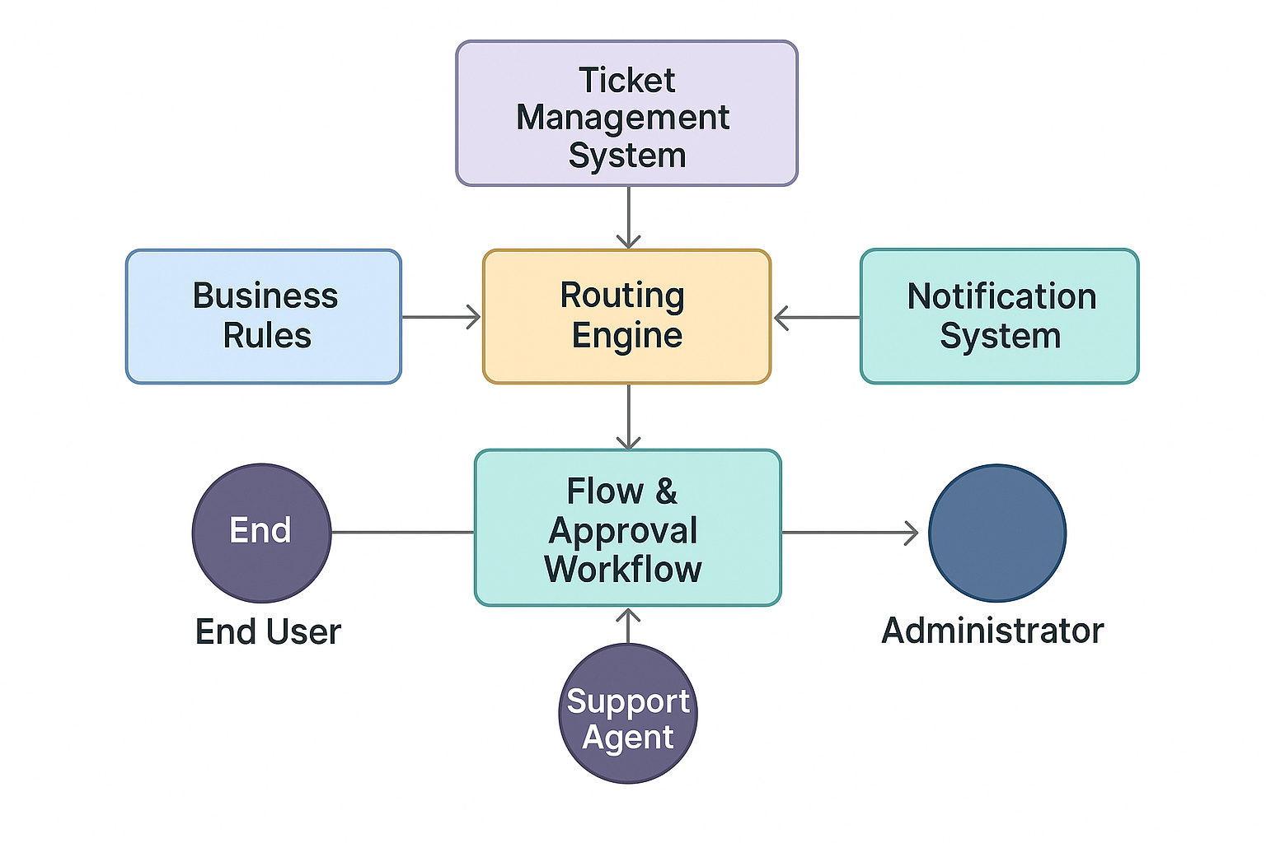

**3. Technology Stack**

| **Layer** | **Technology / Tool** | **Purpose** |
| --- | --- | --- |
| **Frontend** | ServiceNow Service Portal | User interface for submitting and viewing tickets |
| **Backend** | ServiceNow Platform (Flow Designer, Script Includes) | Automates ticket assignment logic |
| **Database** | ServiceNow Tables | Stores ticket, user, and assignment data |
| **Automation Tools** | Flow Designer / Business Rules | Manages routing workflows |
| **Scripting** | JavaScript (Server-side & Client Scripts) | Implements routing logic and data handling |
| **Notifications** | ServiceNow Email Engine | Sends alerts and status updates |
| **Analytics** | ServiceNow Reports & Dashboards | Tracks ticket metrics and SLA compliance |
| **Deployment** | Update Sets | Moves configurations between environments |

**GENERATIVE AI IN ACTION**

Artificial intelligence has evolved through numerous phases, yet it remains both intriguing and inspiring to witness machines become increasingly capable of crafting poetry, humor, and responses that uncannily mimic human creativity. You’ll learn about the history of AI, how deep learning plays a pivotal role in generative AI (“gen AI”), and how gen-AI works and is applied to various industries. Throughout this course, you will also learn how to create algorithms, and gain hands-on experience writing code using popular programming languages.

Completed the following required modules to earn an industry-recognized IBM SkillsBuild digital credential called **Generative AI in Action:**

1. Introduction to Generative AI
2. Crafting Precision Prompts with Generative AI
3. Coding Simplified with Generative AI

After completing Generative AI in Action, I was able to:

* Explain how generative artificial intelligence works
* Define what foundation models are and their role in machine learning
* Understand how transformers models are used to solve various language-related tasks
* Describe how prompt engineering improves generative AI models
* Identify common prompt elements
* Explore code generation using a natural language prompt
* Describe prompt engineering techniques
* Perform common programming tasks using Python’s built-in functions and libraries
* Create scripts and code for solving real-world problems and automating routine tasks

**MODULE 1 -****Introduction to Generative AI**

In this course, I have learned about the history of AI, how deep learning plays a pivotal role in generative AI (gen-AI), and how gen-AI works and is applied to various industries. I also learned how to create algorithms, and gain hands-on experience writing code using popular programming languages.

After completing this module, I was able to:

* Explain how generative artificial intelligence (gen-AI) works
* Define what foundation models are and their role in machine learning
* Understand how transformers models are used to solve various language-related tasks
* Describe how prompt engineering improve generative AI models
* Perform common programming tasks using Python's built-in functions and libraries
* Create scripts and code for solving real-world problems and automating routine tasks

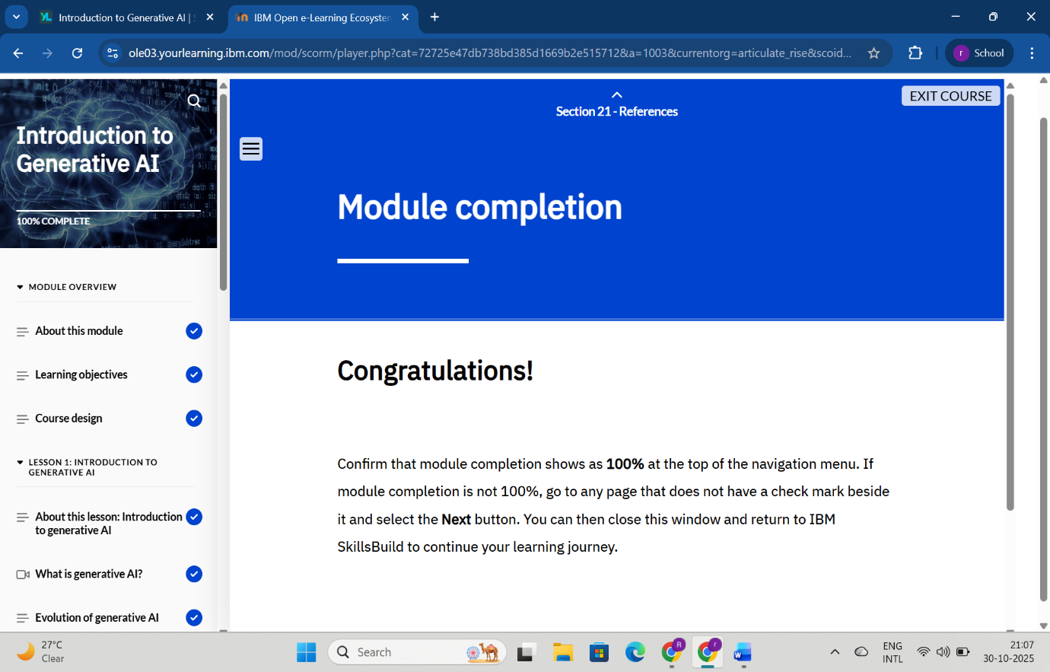

**MODULE 2- Crafting Precision Prompts with Generative AI**

This was an activity-based course. I learned about AI language models and the rules to follow when giving instructions, or prompting, an AI language model. I walked-through a guided activity that demonstrates how to write effective prompts for an AI language model to help plan a travel itinerary. Finally, I participated in an activity to apply what I learned to effectively write prompts for an AI language model to create my own custom music playlist.

After completing this course, I was able to:

* Describe an AI language model
* Explain how an AI language model understands and responds to humans
* Identify the rules to follow to write effective prompts to generate focused and accurate results from an AI language model
* List the steps to sign up for a ChatGPT account
* Follow the steps to effectively write and refine a series of prompts for ChatGPT for a travel itinerary scenario
* 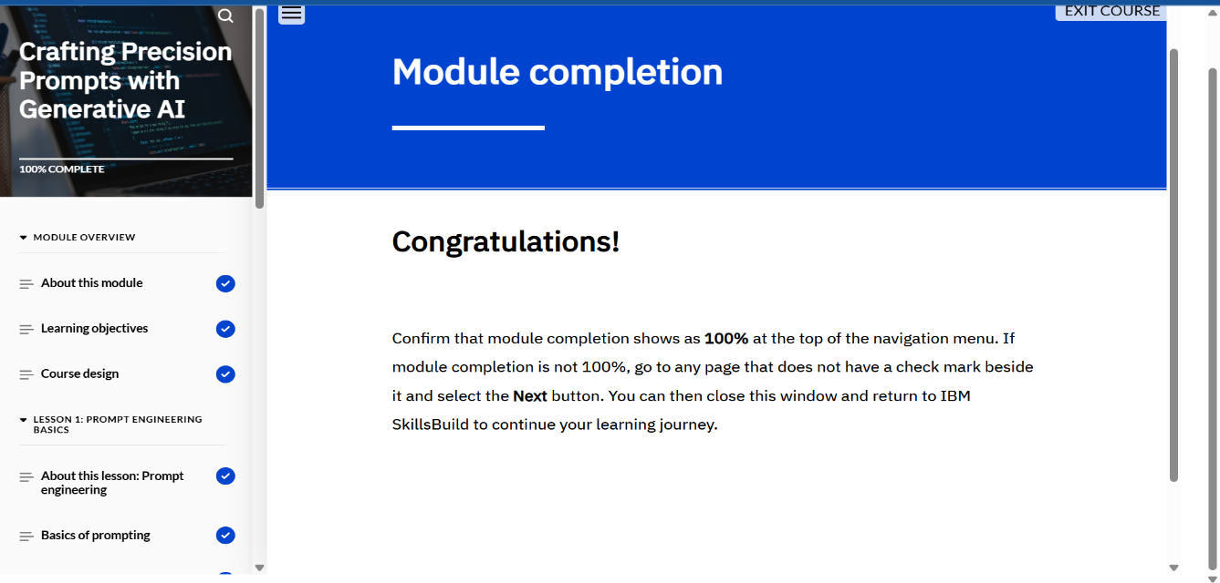Demonstrate the steps to effectively write and refine a series of prompts for ChatGPT to create a custom music playlist

**MODULE 3- Coding Simplified with Generative AI**

In this course, I had learned the basics of scripting, understand its distinctions from traditional programming, and explore how generative AI models are used to simplify and streamline code generation. Through hands-on labs, I also learned how to create algorithms and apply my skills using widely used programming languages.

After completing this module, I was able to:

* Define scripting and how it is works
* Explain the differences between scripting and traditional programming and when each approach is used
* Describe how Python is used to perform various tasks
* 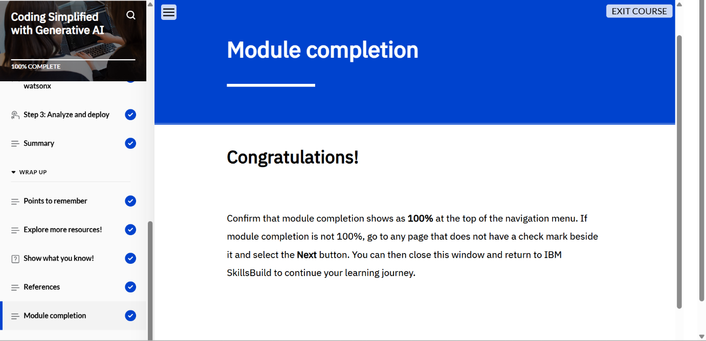Create a working Python application using IBM watsonx Code Generation

**CONCLUSION**

The Generative AI in Action program provided a solid foundation in understanding the core principles and practical applications of generative artificial intelligence. Through the three modules—Introduction to Generative AI, Crafting Precision Prompts with Generative AI, and Coding Simplified with Generative AI—I developed a deep understanding of how AI models such as foundation and transformer models function, and how prompt engineering enhances their effectiveness. The hands-on activities improved my ability to craft accurate prompts, automate coding tasks, and generate creative as well as technical outputs using Python and AI-assisted tools. Overall, this program strengthened my knowledge of AI-driven innovation, improved my coding proficiency, and equipped me with essential skills to apply generative AI techniques in real-world scenarios across multiple industries.

**WELCOME TO SERVICE NOW**

**Practice Scenarios for ServiceNow Admin**

1**.Create a new user for a contractor, assign them to an "IT Support" group, and ensure they can only access the *Incident* application.  
Solution:**

### **Create the Contractor User**

* Navigate to **Users** → *User Administration > Users*.
* Click **New**.
* Fill in details:
  + **User ID**: contractor1
  + **First name / Last name**: Contractor User
  + **Email**: contractor1@gmail.com
  + **Active**: Checked.
* Save.

### **Assign the User to the "IT Support" Group**

* On the user record, scroll to **Groups** (related list).
* Click **Edit**.
* Add to the **IT Support** group.
* Save.

### **Restrict Access to Only the Incident Application**

Now we need to make sure this contractor can only work with **Incident**.

#### **Option A: Role-Based Control (Mostly Preferred)**

* By default, Incident application requires **itil** role.
* Instead of giving full **itil** access (which gives too much), do the following:
  + Create a **new custom role**, ex: **incident_contractor**.
  + Assign this role only to permissions needed for Incident (using ACLs).
  + Assign the new role to your contractor user.
  + Do **not** give **itil** or other broad roles.

#### **Option B: Application Menu Restriction**

* Go to **System Definition > Application Menus**.
* Open the **Incident** application menu.
* In the **Roles** field, add your custom role (**incident_contractor).**
  + This ensures only users with this role can see the Incident.

### **Verify Access**

* **Impersonate** the contractor user.
* Check:
  + They should only see the **Incident application** in the left nav.
  + They can open/create/edit incidents (based on the ACLs you configured).
  + They cannot access other apps (like Change, Problem, etc.).

2. **Assign a role to a new group so members can read *Knowledge Articles* but cannot create or edit them.**

#### **Create a New Group**

* Navigate to User Administration > Groups.
* Click New.
* Enter a Name for the group (e.g., Knowledge Readers).
* Optionally, add a Description.
* Click Submit.

#### **Assign the Appropriate Role**

To allow read-only access to Knowledge Base articles, assign the **knowledge** role:

* Open the newly created group.
* Scroll to the Roles related list.
* Click Edit.
* Add the role: knowledge
  + This role allows users to view published articles.
* Click Save.

**\*\***Do NOT assign roles like **knowledge_admin or knowledge_manager,** which grant create/edit permissions.

#### **Add Users to the Group**

* In the group record, scroll to the Group Members related list.
* Click Edit.
* Select users you want to add.
* Click Save.

#### **Verify Access**

* Log in as one of the group members.
* Navigate to Knowledge > Articles.
* Confirm they can view articles.
* Try creating or editing an article — they should not have access.

3. **Configure a UI Policy that hides the "Work Notes" field unless the state is "In Progress"**.  
**Solution:**

* **Navigate to UI Policies**
* Go to Application Navigator → type UI Policies → click System UI > UI Policies.
* Create a New UI Policy
* Click New.
* Select the Table → e.g., *Incident* (or whichever table you’re working on).
* Provide a Name (e.g., *Hide Work Notes unless In Progress*).
* In the Conditions section, set:
  + Field = *State*
  + Operator = *is*
  + Value = *In Progress*.
* Check the box Active.
* Save the record.
* **Add a UI Policy Action**
* In the same UI Policy record, scroll to UI Policy Actions (Related List).
* Click New.
* Configure the action:
  + Field name = *Work notes*
  + Visible = *True* (since you want it visible only when the condition is met).
* Submit the action

4. **Configure a UI Policy to hide Notes section in incident, when state is In Progress.**

**Solution**:

* **Navigate to UI Policies**
* Go to Application Navigator → type UI Policies → click System UI > UI Policies.
* Create a New UI Policy
* Click New.
* Select the Table → e.g., *Incident* (or whichever table you’re working on).
* Provide a Name (e.g., *Hide Work Notes unless In Progress*).
* In the Conditions section, set:
  + Field = *State*
  + Operator = *is*
  + Value = *In Progress*.
* Check the box Active.
* Save the record.
* **Make Run Script box True**
* Just write one line of code:
* g_form.setSectionDisplay(‘notes’,false);
* Submit the action

5. **Configure a response SLA, the SLA should pause, when the incident state is in On Hold vice versa**.

#### **Create or Modify an SLA Definition**

* Navigate to **Service Level Management > SLA Definitions**.
* Click **New** or open an existing SLA (e.g., "Response SLA").
* Fill in the basic details:
  + **Name**: Response SLA
  + **Table**: **Incident**
  + **Type**: Response
  + **Duration**: Set your desired time (e.g., 1 hour)

#### **Set SLA Conditions**

* Under the **Start Condition**:
  + Example: **State is New**
* Under the **Stop Condition**:
  + Example: State is Resolved or Closed
* Under the **Pause Condition**:
  + Add: **State is On Hold**

This ensures the SLA timer **pauses** when the incident is moved to **On Hold**, and **resumes** when it returns to another **New** state

#### **Test the SLA Behavior**

* Create a test incident.
* Confirm SLA starts when an incident is created.
* Change state to **On Hold** — SLA should pause.
* Change back to **Active** — SLA should resume.
* Resolve the incident — SLA should stop.

6.**Configure an email notification that alerts the assigned group whenever a new *Change Request* is created.**

**Solution:**

* **Navigate to Notifications**
* In the **Application Navigator**, type **Notifications**.
* Go to **System Notification > Email > Notifications**.

### **Create a New Notification**

1. Click **New**.
2. Fill in the basic details:
   1. **Name**: *New Change Request Assigned Group Alert*
   2. **Table**: *Change Request [change_request]*
   3. **Active**: Checked

### **Define When to Send**

1. Under **When to send**, configure:
   1. **When to send**: *Insert* (since you want this when a new record is created).

### **Define Who Will Receive**

1. In the **Recipients** tab:
   1. Under **Users/Groups in fields**, choose **Assigned to group** (or the field name for assigned group).
   2. This ensures the entire assigned group gets the email.

### **Define What Will Contain**

* In the **What it will contain** tab:
  + **Subject**: New Change Request Created - ${number}

**Message HTML** (sample):  
  
A new Change Request has been created.

* + Number: ${number}
  + Short Description: ${short_description}
  + Requested By: ${requested_by}
  + Assignment Group: ${assignment_group}
  + State: ${state}

Please review and take necessary action.

### **Save & Test**

* Save the Notification.
* Create a new **Change Request** record, assign it to a group.
* Verify that the email goes out to all members of the Assigned Group.

7. **Create a report showing the number of incidents opened by each department in the last 30 days.**

#### **Navigate to Reports**

* Go to Reports > Open Reports Modules.
* Click Create a Report.

#### **Define Report Source**

* Name: **Incidents by Department - Last 30 Days**
* Source Table: **Incident**

#### **Set Conditions**

* **Under Filter, add:**
  + Opened At → on or after → Today - 30 days
  + Department → is not empty ***(optional, to exclude unassigned)***

#### **Choose Report Type**

* Select Type: **Bar Chart** or **Pie Chart** (or **List** if you prefer tabular view)

#### **Configure Grouping**

* Under Group By, select: **Department**
* Under Aggregation, choose: **Count**

#### **Save and Run**

* Click Save.
* Click Run to view the report.

8. **Build a dashboard for Service Desk Managers showing KPIs like incidents by priority, created within a week, state wise also.**

#### **Step 1: Create Individual Reports**

**You’ll need to create three separate reports first:**

#### **Incidents by Priority**

* Go to: Reports > Create New
* Name: Incidents by Priority
* Source Table: Incident
* Type: Bar Chart or Pie Chart
* Group By: Priority
* Aggregation: Count
* Filter: Opened At → on or after → Today - 30 days

#### **Incidents Created Within a Week**

* Name: Incidents Created - Last 7 Days
* Source Table: Incident
* Type: Time Series or Bar Chart
* Filter: Opened At → on or after → Today - 7 days
* Group By: Opened At (Daily)
* Aggregation: Count

#### **Incidents by State**

* Name: Incidents by State
* Source Table: Incident
* Type: Bar Chart or Pie Chart
* Group By: State
* Aggregation: Count
* Filter: Opened At → on or after → Today - 30 days

#### **Step 2: Create a Dashboard**

* Go to Self-Service > Dashboards.
* Click Create New Dashboard.
* Name: **Service Desk Manager KPIs**
* Add a Proper Description
* Click Submit.

#### **Step 3: Add Reports to the Dashboard**

1. Open the newly created dashboard.
2. Click Edit Content.
3. Use Add Reports to include:
   * **Incidents by Priority**
   * **Incidents Created - Last 7 Days**
   * **Incidents by State**
4. Arrange the widgets as needed for clarity.

9. **Restrict the ability to delete records in the *Change Request* table so only users with the "admin" role can do so.**

### **Navigate to Access Control (ACLs)**

* In the **Application Navigator**, type **Access Control**.
* Go to **System Security > Access Control (ACL)**.

### **Create a New ACL Rule**

* Click **New**.
* Fill in details:
  + **Type**: *record*
  + **Operation**: *delete*
  + **Table**: *Change Request [change_request]*
  + **Name**: *(auto-populates when you pick table + operation)*

### **Define the Condition / Role**

In the **Requires role** field, add: **admin**

* This ensures only users with the **admin** role can delete records.

### **Save & Test**

* Save the ACL.
* Test with a non-admin user → they should **not** see the delete option (or get a permission error if they try via URL).
* Test with an admin user → delete should work normally.

10. **Create a custom table and create two reference fields (ex: assignment group and assigned to). Display the users based on selection of assignment group.**

### **Create a Custom Table**

1. In the Application Navigator, type **Tables**.
2. Go to **System Definition > Tables**.
3. Click **New**.
   * Name: *u_custom_task*
   * Label: *Custom Task*.
   * Save.

### **Add Fields**

1. Open your table and go to the **Columns** tab.
2. Add two reference fields:
   * **Assignment Group** → Type = *Reference*, Table = *sys_user_group*.
   * **Assigned To** → Type = *Reference*, Table = *sys_user*.

### **Configure Reference Qualifier on "Assigned To"**

* We need to filter "Assigned To" users based on the selected Assignment Group.

#### **Using Reference Qualifier**

* Right click on the **Assigned To** field, click on **Configure Dictionary.**
* Go to **Dependent** Section, give the name of the Assignment Group(ex: u_ass_group)
* Update and Test the functionality.

11.**How to auto assign incidents when user selects a category as network, the same incident be assigned to Network group.**

**Solution:**

1. Go to Flow Designer → Designer.
2. Click New Flow.
   * Name: Assign Incident by Category
   * Trigger: Created or Updated → Table = Incident
3. Add a If action (Condition) with expression:
   * Select Trigger Record Category is Network
4. Under the If branch, add Action → Update Record:
   * Record: Trigger → Incident(Trigger Record)
   * Set field Assignment group → Network
5. Save and Activate the flow.
6. Test the Flow.

**12. HR Groups members are only able to see HR Related Records in servicenow?**

**Solution:**

### **Step 1: Create a Role for HR Access**

### Navigate to: User Administration → Roles → New

1. Enter:
   * Name: hr_access
   * Description: Role to allow access to HR Cases
2. Click Submit.

### **Step 2: Assign the Role to HR Group**

1. Navigate to:  
    User Administration → Groups
2. Open your HR group record.
3. In the Roles tab → click Edit.
4. Move hr_access from Available → Selected.
5. Click Save.

Now all members of the HR group have the hr_access role.

### **Step 3: Create Access Control (ACL) for Viewing HR Cases**

1. Navigate to:  
    System Security → Access Control (ACL)
2. Click New.

Fill in:

|  |  |
| --- | --- |
| **Field** | **Value** |
| Type | record |
| Operation | read |
| Table | Your HR Case table |
| Active | True |

### **Step 4: Define Access Condition (No Script)**

Scroll down to the Requires role section:

* Add the Role hr_access.

This means only users with the hr_access role can read/view HR Case records.

### **Step 5: Save and Test**

1. Click Submit or Update to save the ACL.
2. Impersonate a non-HR user:
   * Go to your profile → click Impersonate User → choose a user *not in the HR group*.
   * Try opening an HR Case record → You should see a “Security constraints prevent access to requested page” message.
3. Now impersonate an HR group member:
   * They should be able to open HR Cases normally

**13. When the Incident state changes to In Progress, Child incident related list should be hidden.**

**Solution:**

1. Navigate to System UI → UI Policies → New.
2. Fill the header:
   * Name: Hide related lists when State is In Progress
   * Table: Incident
   * Active: checked
   * Global: checked
3. Condition: **State is In Progress**  
    (Use the exact label used in your instance for the In Progress state.)
4. Submit the UI Policy record.
5. In the UI Policy record click **New** under **UI Policy Actions**.

Set:

* **Field name:** select the related list–Child incident
* **Visible:** false
* **Read only:** optional
* Save and Test the UI Policy Action.

**14.How to Display Incident number while loading the incident form**

**Solution:**

1. Navigate to System UI → Client Scripts → New.
2. Fill the header:
   * Name: Show Incident Number on Load
   * Table: Incident
   * Type: onLoad
   * Active: True
3. Add this script:

function onLoad() {

// Get the Incident number field value

var incNum = g_form.getValue('number'); // 'number' is the field name

alert('Incident Number: ' + incNum);

}

**15. When the Incident state changes to In Progress, description should be hidden and short description should be mandatory.**

**Solution:**

## **Step 1 — Navigate to Client Scripts**

1. Go to:  
    System UI → Client Scripts → New
2. Fill the header:
   * Name: Hide Description and Make Short Description Mandatory
   * Table: Incident
   * Type: onChange
   * Field name: state
   * Active: checked

**Step 2 — Add the Client Script Code**

function onChange(control, oldValue, newValue, isLoading) {

if (isLoading) return;

if (newValue === '2') {

g_form.setDisplay('description', false);

g_form.setMandatory('short_description', true);

} else {

g_form.setDisplay('description', true);

g_form.setMandatory('short_description', false);

}

}

* Click **Submit** or **Update** to save.

**15**. **If the description field is empty in the incident table, prevent the form submission.**

**Solution:**

## **Step 1 — Navigate to Client Scripts**

1. Go to:  
    System UI → Client Scripts → New
2. Fill the header:
   * Name: Prevent Submit if Description Empty
   * Table: Incident
   * Type: onSubmit
   * Active: checked

**Step 2 — Add the Client Script Code**

function onSubmit() {

var description = g_form.getValue('description');

if (description == '') {

g_form.addErrorMessage('Description cannot be empty');

return false;

} else {

return true;

}

}

**16. Users can not change the state field values in the incident list.**

**Solution:**

## **Step 1 — Navigate to Client Scripts**

1. Go to:  
    System UI → Client Scripts → New
2. Fill the header:
   * Name: Prevent State Inline Edit
   * Table: Incident
   * Type: onCellEdit
   * Field name: state
   * Active: checked

**Step 2 — Add the Client Script Code**

if(newValue==2){

alert(‘You can not edit this value’);

saveAndClose==false;

}else{

saveAndClose==true;

}

**17. How to set the Caller to Logged in user automatically in the incident table.**

**Solution:**

1. Navigate: System Definition → Business Rules → New
2. Fill the details:
   * Name: Set Caller on Incident Create
   * Table: Incident
   * When: before
   * Insert/update: checked
   * Advanced: true
3. **Script**:

current.caller_id = gs.getUserID();

**18.When a user updates an incident record, priority should change to Critical automatically.**

**Solution:**

1. Navigate: System Definition → Business Rules → New
2. Settings:
   * Name: Set Priority field
   * Table: Incident
   * When: before
   * Update:checked
3. Script:

current.impact = 1;

current.urgency = 1;

**19.Create a button on the Incident form that allows users to mark an Incident as Resolved with a single click.**

**Solution:**

1. Navigate: System UI → UI Actions → New
2. Settings:  
   * Name: Resolve Incident
   * Table: Incident
   * Action type: Form button
   * Active: checked
3. Script:
   * current.state = 6;
   * current.update();
   * action.setRedirectURL(current);

**20.Create a button on the incident table that copies the Short Description value into the Description field.**

**Solution:**

1. Navigate: System UI → UI Actions → New
2. Settings:
   * Name: Copy Short Description
   * Table: Incident
   * Action type: Form button
   * Active: checked
3. Script:
   * current.description = current.short_description;
   * current.update();

action.setRedirectURL(current);